The Window Cleaning Blueprint
How to Make $500 a Day Cleaning Windows

Introduction
In this book we will discover many principles on running a successful window cleaning business.
Do not skip through this book with the intentions of only wanting to learn the
how to stuff and how much to charge for cleaning windows.

That my friend, I promise, Will only lead you down a dead-end road of frustration in this business.

Yes, we will discuss in great detail, exactly how much to charge for cleaning windows in almost every possible scenario.

Yes, we will discuss how to get your hands on a water fed pole system for cheaper than you see on these window cleaning websites.

Yes, we will learn how to overcome the fears of carrying a ladder into a customer's gigantic house and charging them $500 just to clean their windows.

But, this is a mindset business. this business might even be more about mindset than a lawn care business, a plumbing business or a general small business. A professional window cleaning business owner would back me up with that statement.

Most small businesses set a price and that's a wrap. the window cleaning business is rooted almost entirely in the perception of the buyer.

51% or more of this business is rooted in perceptions and luxury. The other 49%
“in my personal opinion” is necessity.
But when it comes to Residential homes. Primarily what we’ll be discussing in this book.
Window Cleaning is a luxury business.

In the more advanced stages of the business. You can acquire large commercial accounts from city buildings, nursing homes, healthcare facilities to libraries and even skyscrapers.

In my opinion, aside from those parameters and environments. Window cleaning is not an absolute necessity to average income people.

In this book I will teach you deep, valuable shortcuts to painful lessons, that I had to learn the hard way.
Because “for the life of me”. I couldn't wrap my mind around the nature of this business.
Not until the day I finally woke up and realized that
the window cleaning business is a luxury business.

Have some patience, and stick with me on this. if you really buckle down and commit.
There's a magic in the process.
Welcome to,

The Window Cleaning Blueprint.

My Promise to You

If you want to start a window cleaning business. I guarantee you that this will be the best book you've ever read on this topic in your entire life.

In this book you will learn how to overcome the many obstacles that a new window cleaning business owner faces from the moment he wakes up to the moment he goes to bed.

Sure, You will learn how to make $500 a day from cleaning windows.
The first I want your full attention. listen to me clearly.

Starting and growing a window cleaning business is simple, but it's not easy.
the functions and modalities of passing out business cards, registering a business, selling jobs, cleaning windows and collecting money... are a piece of cake.

All that stuff is a joke in comparison to the immense amount of frustration It takes to start and grow a successful window cleaning business.

If there's any business that looks easier to start from the outside, it's the window cleaning business. And if there's any business that will make you pull your hair out in total confusion in face of the blatant obvious, my friend, it's the window cleaning business.

Join me in this exciting journey and give me the permission to be your coach as I show you how to successfully start, grow and achieve your dream of not only making some serious money, But own your very own successful window cleaning business.

In This Book You’re Going to Learn

How to start an extremely profitable window cleaning business with low overhead.
Even if you're unsure
“if this thing is really going to work’,
If you have no clue what to charge,
If you have no idea what to say to sell jobs
If you're afraid of investing money and losing it
If you don’t know what the requirements are for getting inside of high-end homes.
If you already have plenty of competition in your city
If you have literally no startup money, “but need money now”

Stick with me and I’ll walk you through step by step,

I have clients that I coach who went from flat broke to getting there window cleaning businesses off the ground and making money in less than a week.
I know quite a few guys personally who make a killing cleaning windows.
My friend Brandon here in Michigan cleans windows and installs gutter guards on huge houses and makes $1,000 a day minimum every single day.
On some weeks, if you clean a bunch of large houses and maybe a large church you can clear $10k in a single week.

I can’t promise you instant results like these guys. Growing a legitimate window cleaning business with a healthy client base takes some time. But I am making a huge promise that there’s definitely
money to be made cleaning window. Windows are literally everywhere.

You can do this … and make lots of money too!

Introduction

So you want to start a window cleaning business?

First, Let me define the major problem.

Starting a window cleaning business can be extremely hard and frustrating.
Not knowing what to charge, feeling overwhelmed by all the competition,
not knowing how to start, where to start, what tools to use,
questioning if you can actually even be successful at it,
how to sell and get jobs, get insurance or a hundred other questions.

I had all these questions too in the beginning.
At times I was very discouraged because no one was there to coach me or help me and I had no choice but to hit the ground running and learn the entire business myself.

So be aware.
In today’s world, the way of doing business is changing very quickly.
There’s a “New Way”, a “New Reality”.
Things are not like they used to be.
And only the latest cutting edge information technology will keep you up to date and ahead of the pack.

This is my reason for creating The Window Cleaning Blueprint.
My goal in this program is to effectively guide you through the minefield and equip you with the right information and tools necessary in order to get your window cleaning business off the ground successfully….and fast!

Hi I’m Keith Kalfas and I own a successful window cleaning business.
I’ve cleaned windows from high profile customers in high end homes making over $2000 profit a day... to cleaning windows at cellphone stores, restaurants, gas stations, sub shops and liquor stores for literally peanuts.

I started broke and desperate and in fear with only $50 in my pocket and nothing but a small business opportunity magazine.
To making tens of thousands of dollars cleaning windows for high profile customers in very large homes in rich neighborhoods.

I went from being vulnerable, insecure and letting my customers take advantage of me.
To growing a backbone, being confident and knowing the true value of my
my hard work and my service.

And… Made some pretty decent money as well…
So can you!!

You can do it too. Let me repeat this, and I’m making a huge promise right up front.
You can totally do this too….and even more so.

Keep reading.
Because if you want to start a window cleaning business I promise you this book will change your life forever.

Because if you keep reading, this is what you’ll learn.

- Current state of Window Cleaning Business / How some window cleaners make a ton of money and others don’t
- (Good News)How the window cleaning business has changed and how exciting it is
- (Bad News) is that Most Window Cleaners don’t succeed
- Talk about (Who wins and who loses) in this new world "Integrity, Authenticity"
- Biggest Obstacles that people face..
- How to make a ton of money in the Window Cleaning Business
- Tools Techniques and tips
- Pricing and selling tips
- How to actually set up and register your business
10.)How to market your business online and offline
And much more more.
Give me the permission to be your coach, strap yourself in, and welcome to
The Window Cleaning Blueprint.

Also, if you go to www.WindowCleaningBlueprint.com.
There’s an entire video training course online that goes along with this book.
Including property walks, on the job training and real time pricing videos.
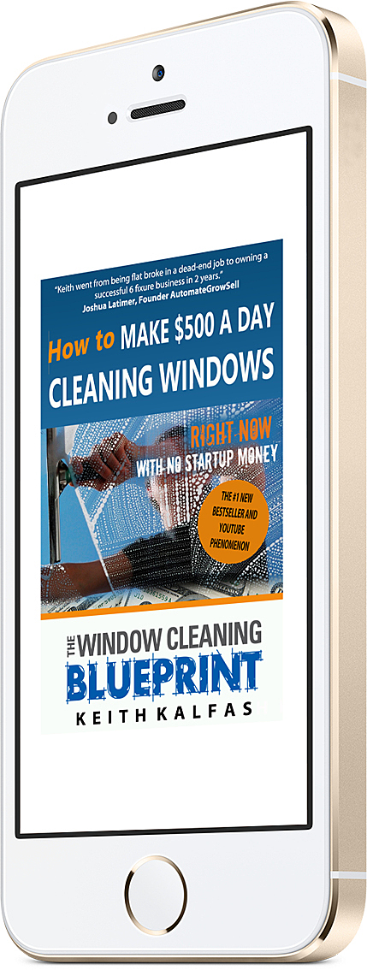
How to Make $500 a Day Cleaning Windows (Ebook)
http://nhft9abp.megaph.com/?skip-tracking=true

Or on Paperback below
Get How to Make $500 a Day Cleaning Window (On Paperback)
By Keith Kalfas
Click below
http://tinyurl.com/j4hhngj

